The LB&SC A1x. 50 locomotives of this class were constructed at Brighton works by the London, Brighton and South Coast Railway (LB&SCR). Designed by William Stroudley, between 1874 and 1880 they quickly became known as "Terriers" due to the distinctive 'bark' of the exhaust beat. 10 locomotives exist in preservation.
Features and operation. This model features a 21 pin DCC decoder plug, and/or has been factory fitted with DCC Sound. Non-DCC fitted models require fitting with a decoder before use on a DCC layout. DCC fitted versions will operate on either DC or DCC controlled layouts without modification.
All models are supplied with a speaker housing which can be fitted in the boiler. A suitable speaker can be obtained from DCC Supplies Ltd (01905 621999, www.dccsupplies.com).
A firebox flicker effect is fitted to all models, which will operate continuously under DCC control. On layouts using Analogue (DC) control, the flicker will not operate below approximately 5v of track voltage.
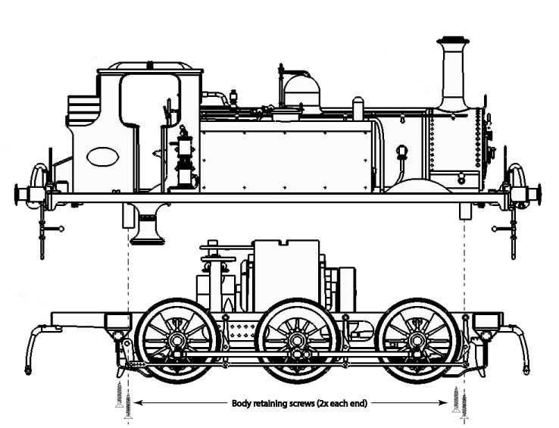
First use and Running in. We suggest that the model is first operated at a medium speed for approximately ½ hour in each direction. During this time correct operation can be verified and the mechanism will free-up. Running in can also be carried out after fitting a DCC decoder, there is no specific requirement to run-in using DC.
DCC Decoder plug
Lubrication. The model has been factory assembled with sufficient lubrication for initial operation. After running in (approximately 1-2 hours), we suggest light lubrication of axles and connecting rods and again after approximately 50 hours running, or after extended storage (especially if stored in a warm/hot location).
Important: Only synthetic oils should be used on your model (we suggest Dapoil, or ‘Locolube’) as other oils may damage the model. When oiling, only 2 or 3 drops should be used, in severe cases, over oiling may invalidate your warranty.
Fitting a DCC decoder. Remove the body by removing the four outermost screws (located in the base of the model). The body will then lift off the chassis in one piece. (If the firebox flicker board becomes loose, it can be replaced onto its mounting on the motor housing.) The DCC blanking plate will be seen fitted to the decoder plug on top of the motor assembly. Carefully unplug this (using thumb and fore-finger) and fit the 21 pin decoder of your choice. If you are fitting sound, the speaker enclosure will be found inside the boiler, and (depending on your decoder instruction sheet) can be either hard-wired to the decoder or to the spare solder pads on the decoder mounting PCB.

